**Muhammad Arsalan Grade 12-O IELTS Writing P3 31/10/2022**

**Writing Task 1**

The charts below show the main reasons for study among students of different age groups and the amount of support they received from employers.

Summarise the information by selecting and reporting the main features, and make comparisons where relevant.

Write at least 150 words.

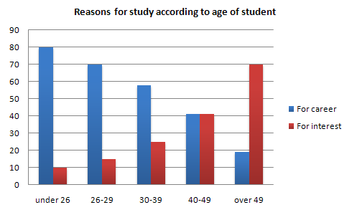 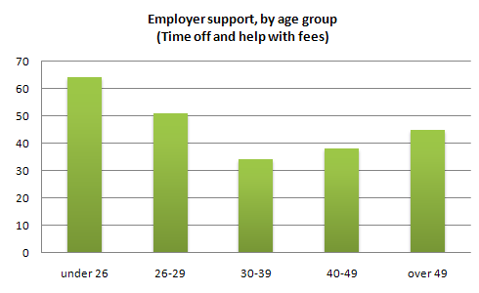

**Writing Task 2**

In some countries young people are encouraged to work or travel for a year between finishing high school and starting university studies.

Discuss the advantages and disadvantages for young people who decide to do this.

Give reasons for your answer and include any relevant examples from your own knowledge or experience.

You should write at least 250 words.